
Kansas City Sports Medicine

Sports Medicine & Arthroscopy
Olathe, KS  Lansing, KS  Kansas City, KS/MO
Ph: 913-351-3005 Fax: 913-351-3009

Prem Parmar, M.D., F.R.C.S.(C)

Sports Medicine and Arthroscopy

Fellow of the Royal College of Surgeons of Canada
Diplomate, American Board of Orthopaedic Surgery

Rehabilitation Program
for Rotator Cuff & Scapular Muscles

Following Shoulder Arthroscopy
(SLAP Lesion Repair)

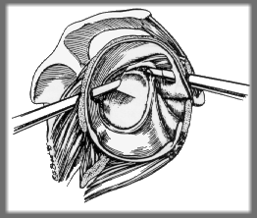

Your shoulder is placed in a sling for 6 weeks following arthroscopic labral (Superior Labrum Anterior Posterior or SLAP) repair. Follow your restrictions during the immobilization period as outlined by your surgeon.

You will see your surgeon approximately 1 week after your surgery. A rehabilitation program may be prescribed at that time.

This exercise program has been designed to provide guidelines and basic instructions for you and your therapist to help restore your shoulder’s range of motion and strengthen your muscles. This program is divided into three phases:

- Phase I: Day One to 4 Weeks After Surgery

Your sling will be removed only to shower and do exercises, which include wrist and elbow movement, ball squeezes, and pendulum exercises (which involve a gentle rotational movement of the shoulder while bending forward to let gravity assist you with the motion).

Simple tasks using your hand in front of your body while keeping your upper arm close to your side are allowed.

** Limit external rotation to 0 degrees for 0-6 weeks **

- Phase II: 4-6 Weeks After Surgery

Continue use of the operative arm for light activities of daily living with your elbow at your side. You may start the following exercises:

Isometric exercises: To prevent wasting of the muscles, isometric exercises can be started. These gentle strengthening exercises are performed without actual movement of the arm.

- Phase III: After Week 6 Following Surgery

You may discontinue sling

Active Assisted Range of Motion Exercises – involve using your good arm to assist your operative arm. Elevation above your shoulder level should be done gently and with minimal discomfort.

** Limit external rotation to only 45 degrees **

Active Range of Motion Exercises – These exercises involve moving your arm actively without assistance. Follow the same instructions for Active Assisted Exercises without using any support from your good arm. Continue with passive stretching exercises. Passive posterior capsular stretching and internal rotation should be emphasized.

Rotator Cuff Muscles provide support Scapular Muscles help to stabilize the shoulder and stability to the shoulder joint. blades for the rotator cuffs to function
properly. These muscles may become weak and painful after shoulder injuries or post-operatively.

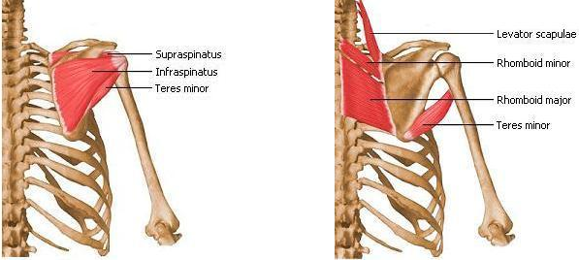

PHASE I: ELBOW, WRIST & HAND EXERCISES

Elbow, Wrist & Hand Mobility
After your shoulder surgery, it is important to maintain full mobility of the joints below the affected shoulder. These exercises should be done 4 to 5 times throughout the day with your sling/brace removed and your elbow tucked in at your side.

Elbow
- In a sitting or lying position, gently bend and straighten your elbow.
- Make sure that your elbow straightens fully.
- Repeat 15 times

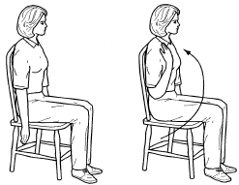
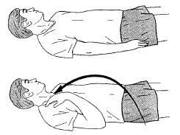

Wrist
- Bend your wrist forward, backward • With your palm open, gently move hand
and in a circular motion side to side
- Repeat 15 times • Repeat 15 times
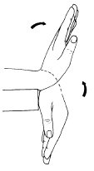
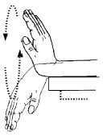
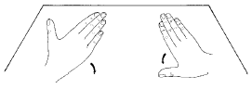

Hand
- Gently open and close your hand making a fist
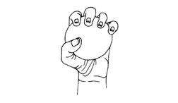
- Squeeze a soft ball
- Repeat 15 times
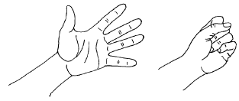

Pendulum Exercises
Bend forward and support your good arm on a table. Swing your operative arm forward and backward, and clockwise and counter-clockwise. Perform this exercise 20 times (2 sets of 10 repetitions).

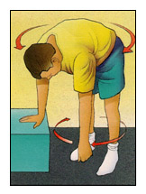

PHASE II: 4-6 WEEKS AFTER SURGERY

Isometric Exercises
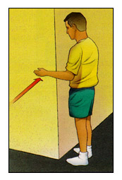
Isometric exercises are performed without actual movement of your arm. To strengthen the muscles that rotate your arm outward, tuck your elbow into your side and press your hand outward against a wall or any solid object (Figure A). To strengthen the muscles that rotate your arm inward, push against your good hand or against the corner of a wall (Figure B).
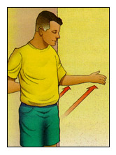

Figure A

Figure B

PHASE III: ACTIVE ASSISTED RANGE OF MOTION EXERCISES – 6 WEEKS AFTER SURGERY

** Range of motion exercises should be performed 4 – 5 times per day **

Shoulder Flexion (Assistive) - Clasp hands together and lift arms above head. Keep elbows as straight as possible (Figure 2). (Active) – Raise arm above head without assistance from good arm (Figure 1). Perform this exercise 20 times (2 sets of 10 repetitions). Hold each time for 5 seconds.
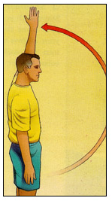
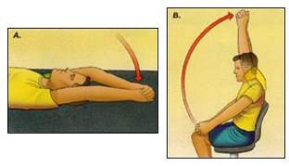

Figure 1

Figure 2

Shoulder External Rotation (Assistive) – Grasping a cane with both hands, push the cane towards the bad arm. (Active) – Keep elbow at right angle and tucked at your side. Slide forearm back and forth. Perform this exercise 20 times (2 sets of 10 repetitions). Hold each time for 5 seconds. Do not force your arm past 45 degrees for the first 12 weeks after surgery.
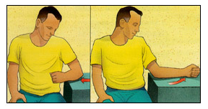

Shoulder Internal Rotation (Assistive) – Use your good arm to pull the affected hand across your back and upward. (Active) – Bring hand behind back and across to opposite side. Perform this exercise 20 times (2 sets of 10 repetitions). Hold each time for 5 seconds.
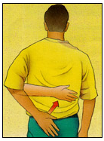

Active Range of Motion Exercises
These exercises involve moving the arm actively without assistance. Follow the same instructions for the active assisted exercises above without using any support from your good arm. Add posterior capsule stretching to your active exercise program.

Posterior Capsule Stretching

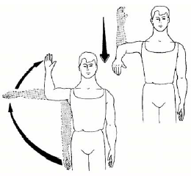
Internal Rotation – Lie on your back with your arm 90 degrees away from your body and your elbow bent at a right angle (fingers pointing toward the ceiling). Move your hand down with the palm toward the bed or floor without changing the angle in your elbow joint. This exercise stretches the back of your shoulder structures. Your physiotherapist may assist with this stretching exercise.

Cross-Chest Adduction – Cross your arm over your opposite shoulder and apply slight pressure on your elbow. This exercise also stretches the structures in the back of your shoulder.
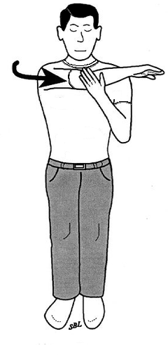

Free Weight & Elastic Band Exercises
Elastic band and free weight strengthening exercises – Elastic bands come in different colors: yellow, red, green, blue, gray, and black. The yellow elastic band is the weakest and offers 1 lb of resistance. You can progress to more resistance as you become stronger. Small objects or dumbbells may be used in association with the elastic bands.

Flexion in Scapular Plane – Rotator cuff muscles become weak while your arm is in the sling. As a result, you need to strengthen them following any shoulder surgery. This can be achieved by light weights and elastic band exercises. Once you are able to move your shoulder throughout it’s full range without pain, you can progress to strengthening exercises with light weights and elastic bands.

Lift your operative arm away from your side to just below your shoulder level. Move your arm slightly forward (30 degrees) from this position as shown in the diagrams. In this position, lower and raise your arm back to shoulder level. You can progress to light free-weights when performing this exercise becomes easy and pain-free without a weight. To avoid stress on your biceps tendon, do not perform these exercises with your palm facing up. Perform this exercise 20 times (2 sets of 10 repetitions). Hold each time for 5 seconds.

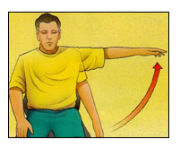

30°

External Rotation

Elastic Band Exercises – Your elbow should be bent at a right angle and tucked at your side. Move your hand out to not more than 45 degrees against the tension of the elastic band. Perform this exercise 20 times (2 sets of 10 repetitions). Hold each time for 5 seconds.

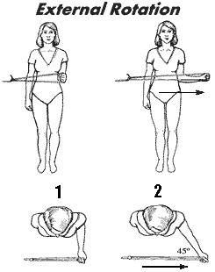

Free Weight Exercises – Lie on your good side. Hold a small weight (about 2 lbs). Your elbow should be bent at a right angle and tucked at your side. Rotate your arm upward within a comfortable range (no more than 45 degrees) by moving your hand up. As your strengthen your muscles you can increase the weight. Perform this exercise 20 times (2 sets of 10 repetitions). Hold each time for 5 seconds.

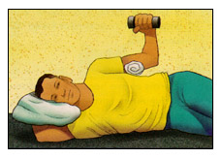

Internal Rotation

Elastic Band Exercises – Your elbow should be bent at a right angle and tucked at your side. Move your hand across your stomach to about 45 degrees. Perform this exercise 20 times (2 sets of 10 repetitions). Hold each time for 5 seconds.

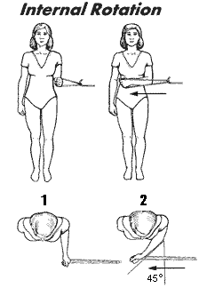

Free Weight Exercises – Lie on your operative side. Hold a small weight (about 2 lbs). Your elbow should be bent at a right angle and tucked at your side. Rotate your arm within a comfortable range by moving your hand up toward your stomach. As your strengthen your muscles you can increase the weight. Perform this exercise 20 times (2 sets of 10 repetitions). Hold each time for 5 seconds.

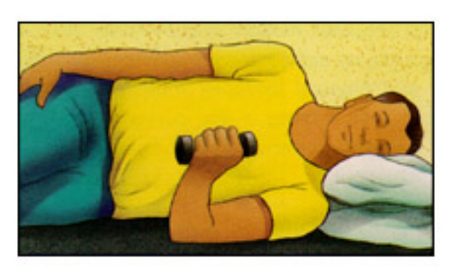

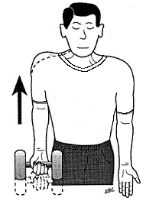Shoulder Shrugs – Raise your shoulders up toward your ears. As you get stronger, you can perform this exercise with weights. Perform this exercise 20 times (2 sets of 10 repetitions). Hold each time for 5 seconds.

Scapular (Shoulder Blade) Exercises

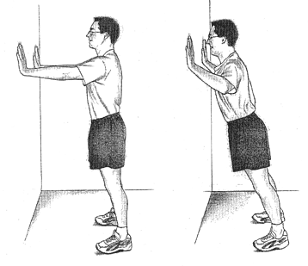
Press-Up Exercises – Push-up exercises are important to strengthen your shoulder blade muscles. Begin with standing push-ups against a wall. Perform this exercise 20 times (2 sets of 10 repetitions). Hold each time for 5 seconds.

* Remember to keep your hands below shoulder level and your back straight

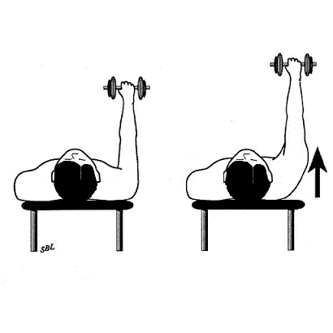
Press Plus Exercises – Lie on your back and stretch your arm up to the ceiling with your elbow straight. Push your arm upward until your shoulder blade is off the table or bed. As you get stronger, you can perform this exercise with a small weight. Perform this exercise 20 times (2 sets of 10 repetitions). Hold each time for 5 seconds.

